Consumer Behaviour Analysis During Diwali Festival Using Python

Project Objectives
The primary objective of this project is to analyze Diwali sales data using Python to understand customer purchasing behaviour and identify factors influencing sales performance. The study aims to:
- Analyze customer demographics such as gender, age, marital status, occupation, and state.
- Identify the customer segments contributing the highest sales.
- Determine the most profitable product categories.
- Examine purchasing trends across different regions.
- Generate business insights that help companies improve marketing strategies and increase revenue during festive seasons.

- Gender Distribution

Female customers are significantly higher than male customers. This indicates that
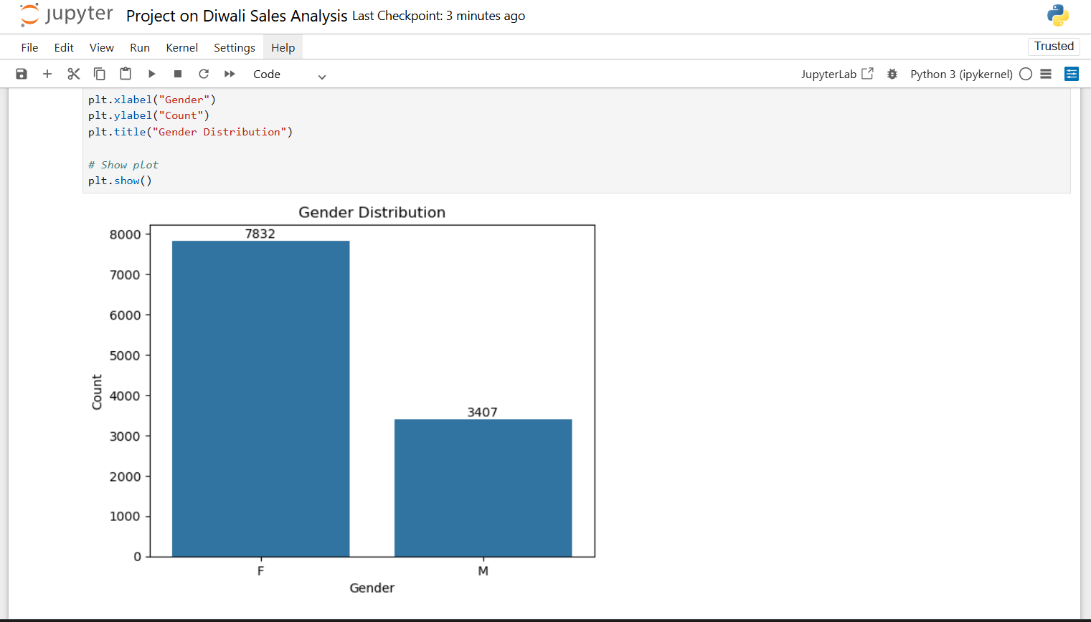
women constitute the majority of customers during Diwali shopping. Business insight is that Companies should design marketing campaigns and promotional offers specially target female customers
2. Total Bought by Each Gender
Female customers generated much higher total sales than male customers. Women not only shop more frequently but also spend more money. Business Insight is that Female consumers are the most valuable customer segment during the Diwali season.
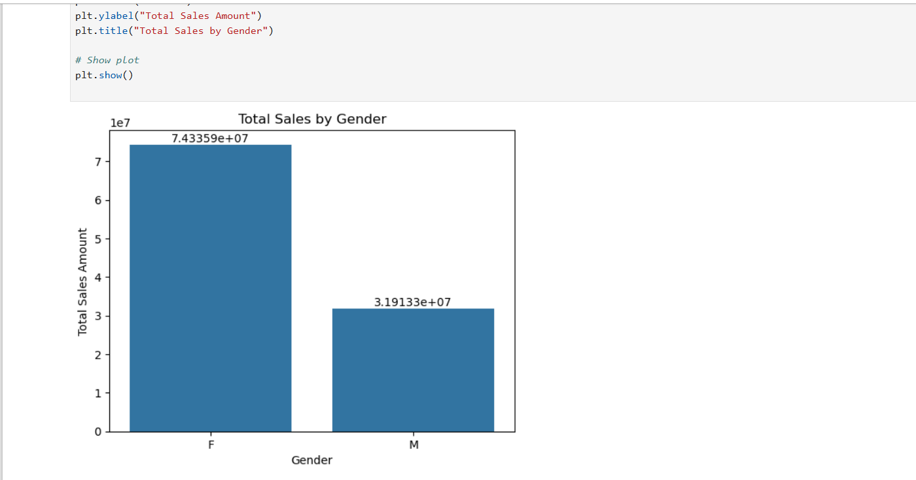
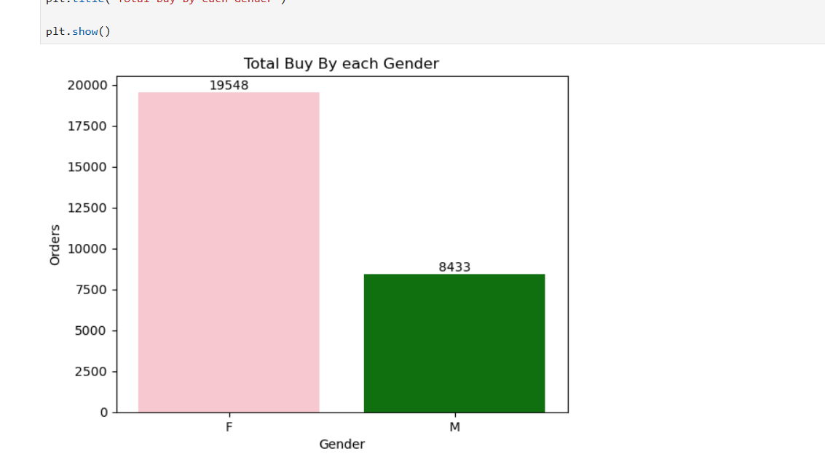
Female Orders more than the male during Diwali Festival. From both above graph show female doing more marketing as compare to male.
3 Age Group Distribution

Customers aged 26–35 years represent the largest customer segment. Business Insight is that Young working professionals are the primary buyers during Diwali. Female customers aged 26–35 years contribute the highest sales among all age groups. Business Insight is that this age group should be the primary target audience for festive marketing campaigns.
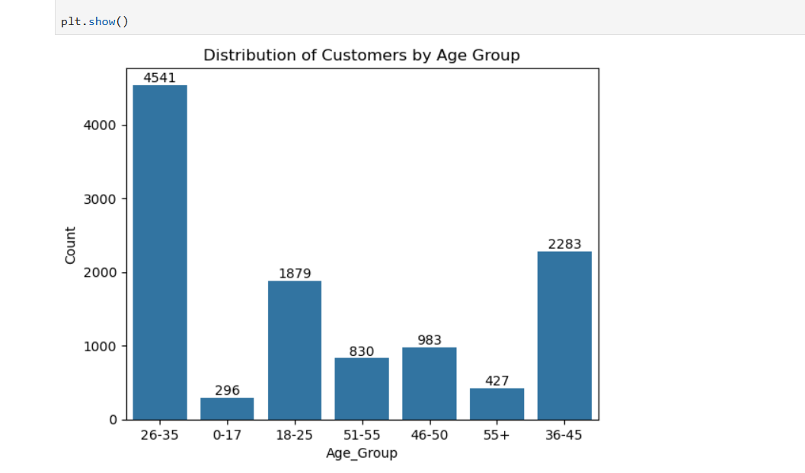
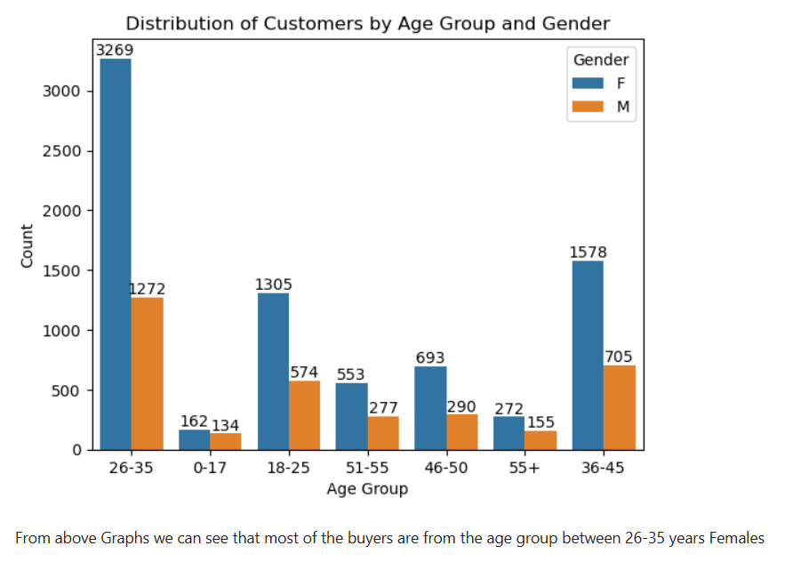
4. Age Group vs Marital Status
Most customers aged 26–35 years are married, indicating that family shopping is dominant during the festival. Business Insight is that Family-oriented product bundles and discounts can improve sales. Marital status value 0 indicate married while 1 indicates unmarried in graph
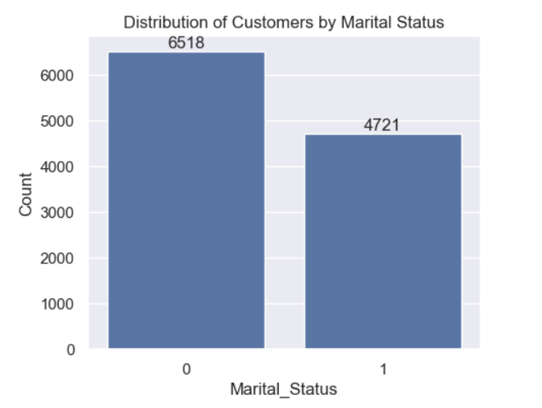
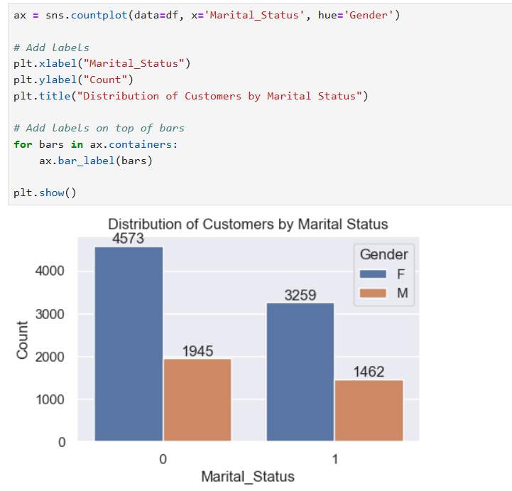
5. State Wise Customer Count
Customer participation varies significantly across states, with metropolitan and economically developed states contributing the largest customer base. Business Insight is that Regional marketing strategies can maximize sales performance.
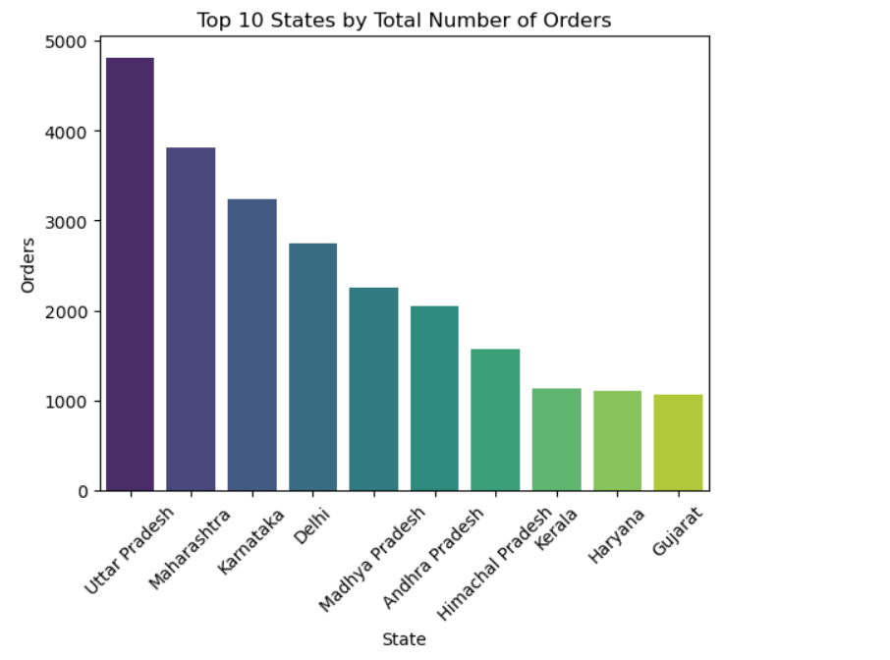
In the graph we show there are only 10 states from which has higher order during Diwali Festivals. All other states also have some order as compare to these states but they have less quantity in order.
The Above shows that Uttar Pradesh, Maharashtra and Karnataka have the highest Orders during the Diwali Festivals. In these states people spending on new things
The highest revenue is generated from Uttar Pradesh Maharashtra Karnataka Delhi showing both high demand and high purchasing power. Business Insight is that Businesses should strengthen logistics and marketing efforts in these states.

6. Product Category-wise Sales
The highest sales are observed in Food, Clothing & Apparel, Electronics, Footwear. Business Insight is that These product categories should receive higher inventory allocation during festive periods.
Product Category-wise Number of Orders
Food and Clothing categories receive the largest number of customer orders.
These categories experience high customer demand and should be prioritized during inventory planning.

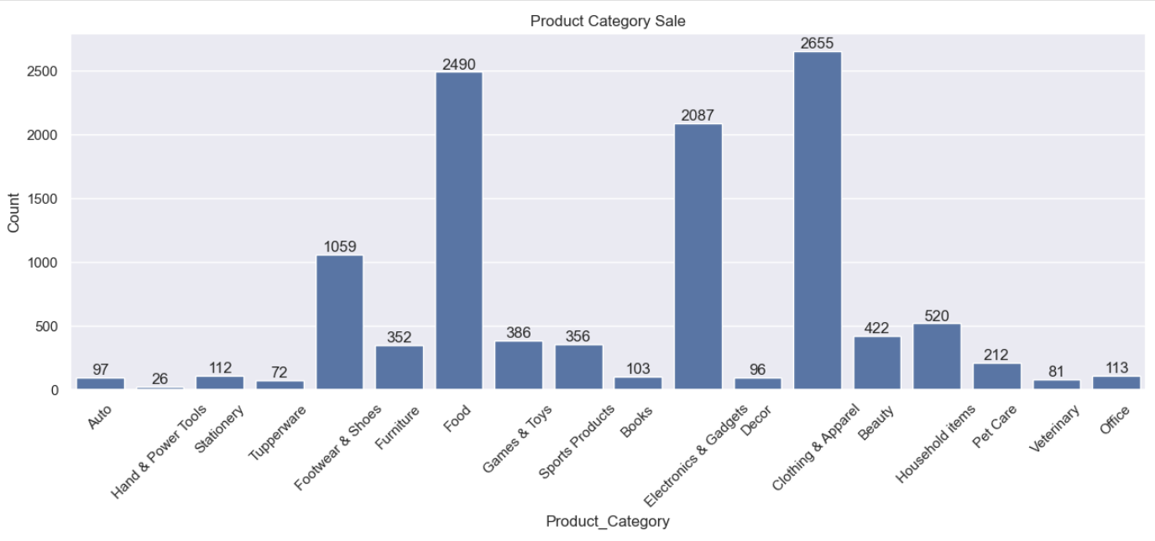

7. Occupation-wise Customer Distribution
The highest number of customers belong to IT Sector, Healthcare, Aviation, Banking while occupations like Agriculture and Textile contribute relatively fewer customers. Business Insight is that Middle- and high-income professionals form the primary customer base.
Occupation-wise Sales Customers working in IT, Healthcare, and Aviation generate the highest sales. Companies can target these professions with premium products and personalized advertisements.
